

**Unit code: CPP006**

**INSTRUCTION FOR OUR DJANGO PROJECT**

**Exercise 1**

Start by forking the repository shared https://github.com/NaftalyMurimi/Django_Student_ATTI_Prj.git

Create your own application baring your name eg Maxwell

In your app create home.html, about.html, sales.html file (as shown below)

Push the changes to the repository with the commit message your name

**Home page**

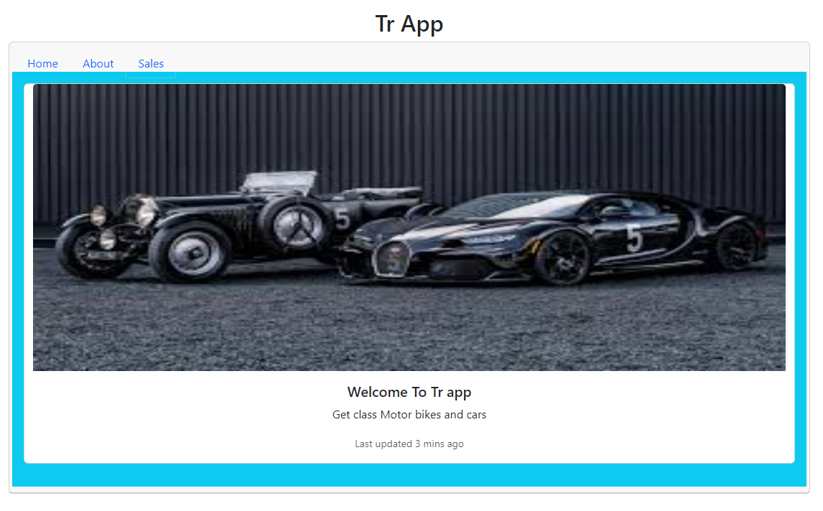

**About page**

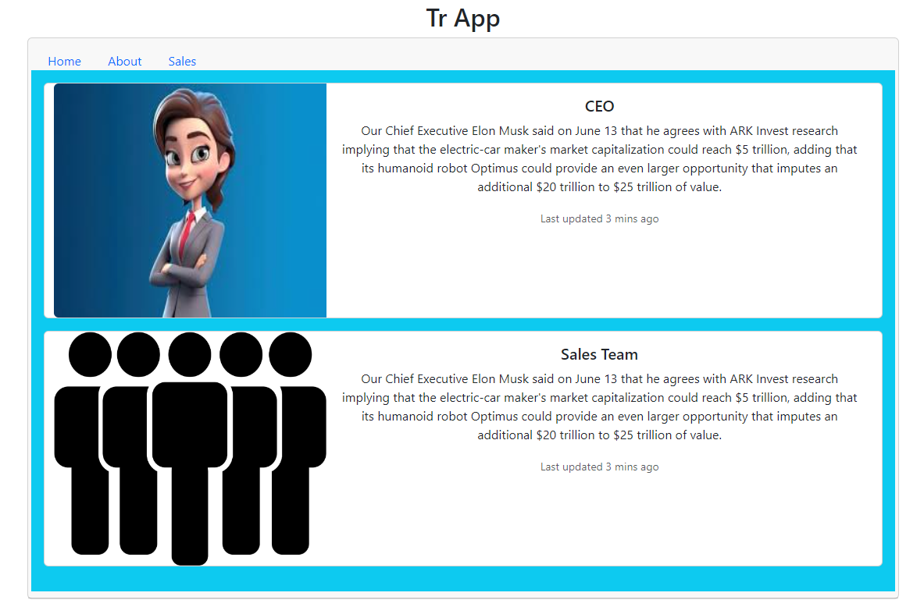

**Sales page**

